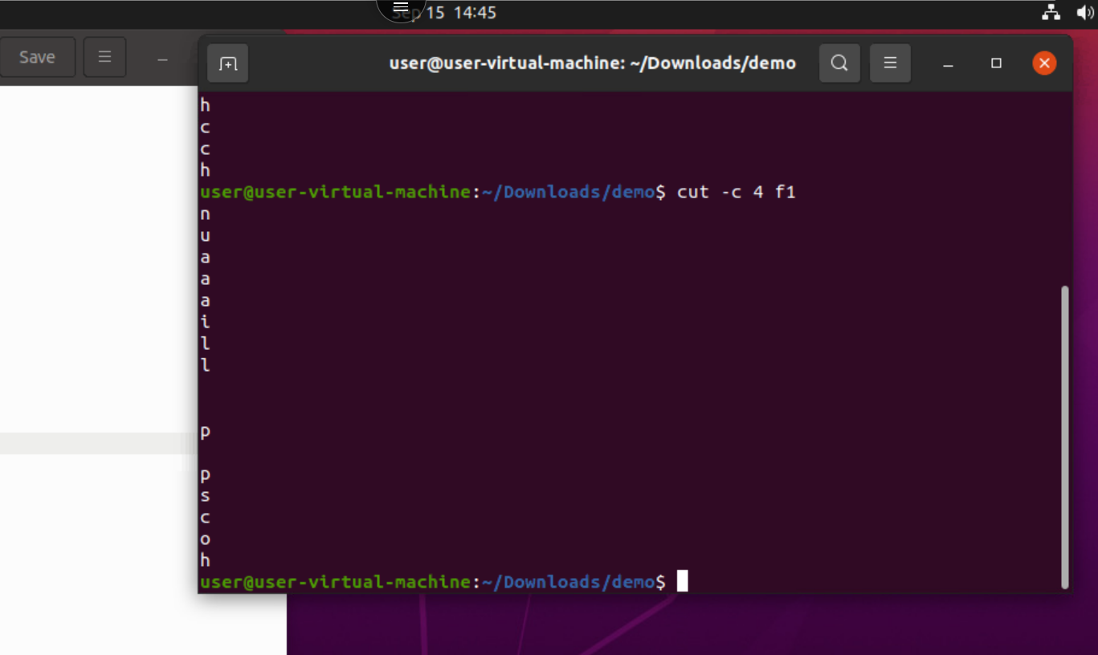
30. cut -c 4 f2 : it will cut the file data at 4th character it will give 4th character of the string

31. cut c 14 f1: this will print column from 1 to 4
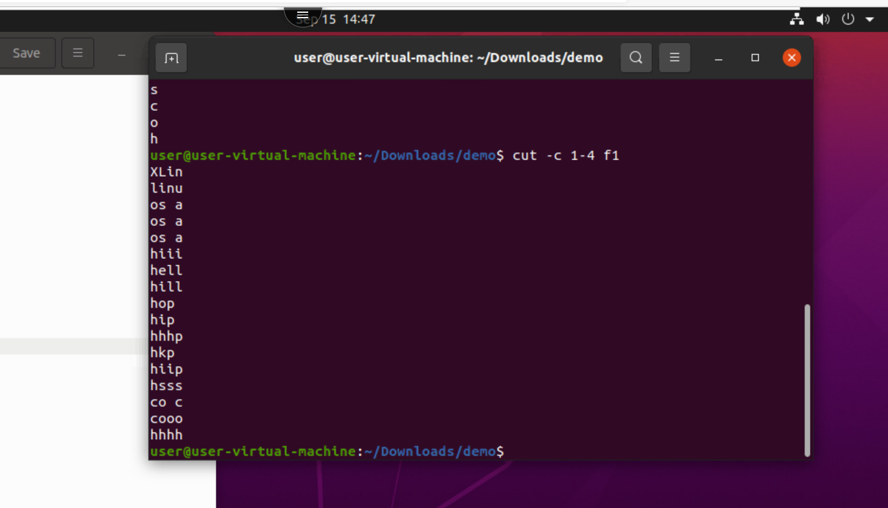

32. cut -c 1- f1: this will cut the column from 1 to last
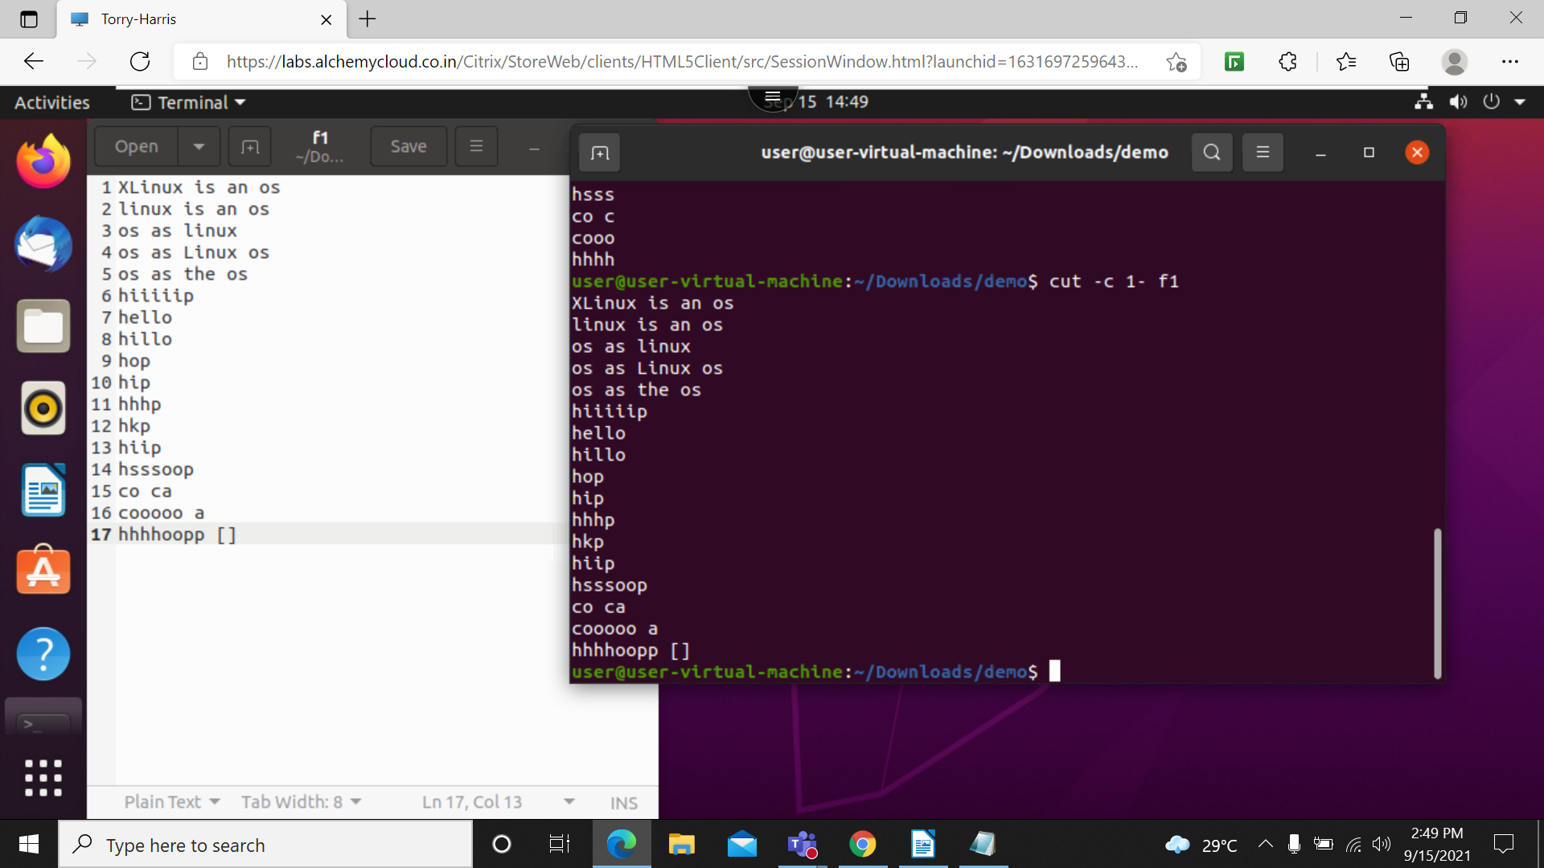

33. cut c 4 f1 : this will print character from 4 to last character
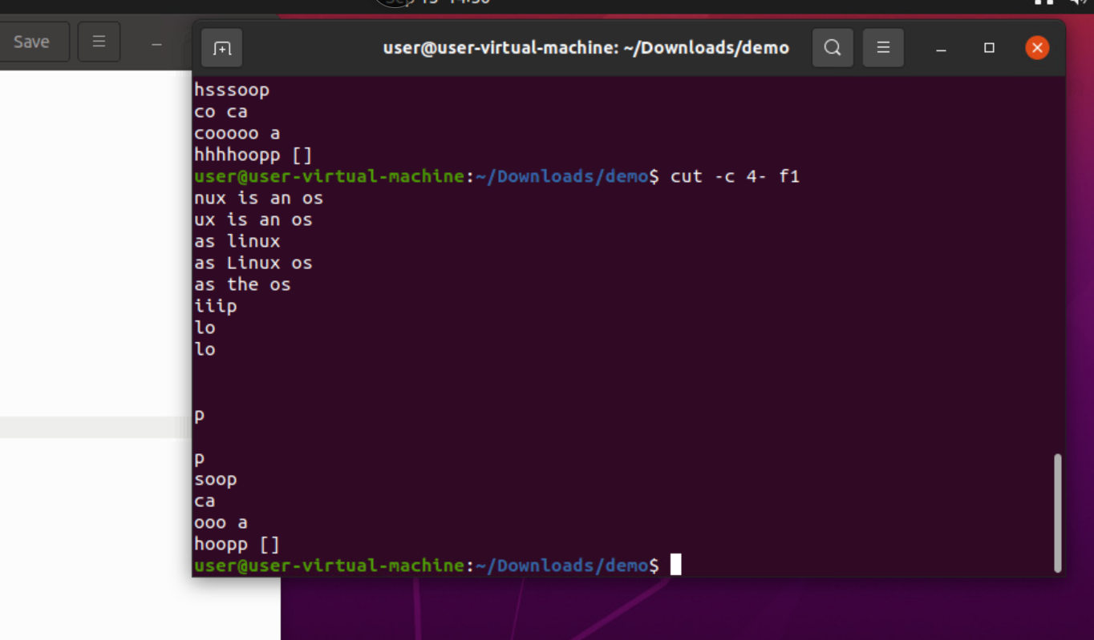

34. cut -c 1,4 f1: this print the 1 and 4 character from the string
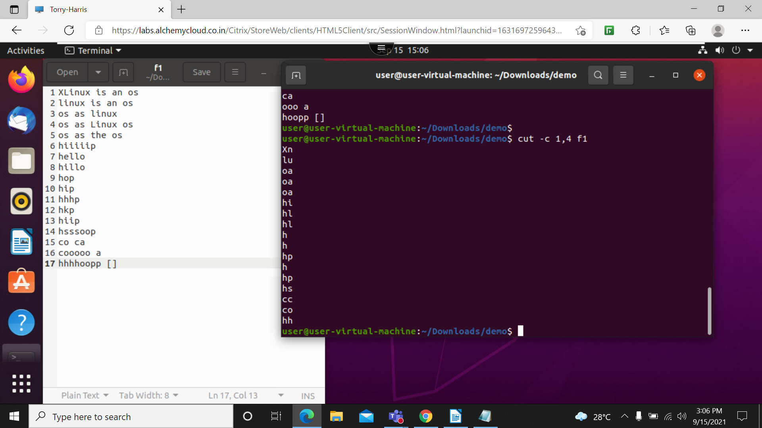

35. cut -c -5 f1: this will print all charector from 1 to 5
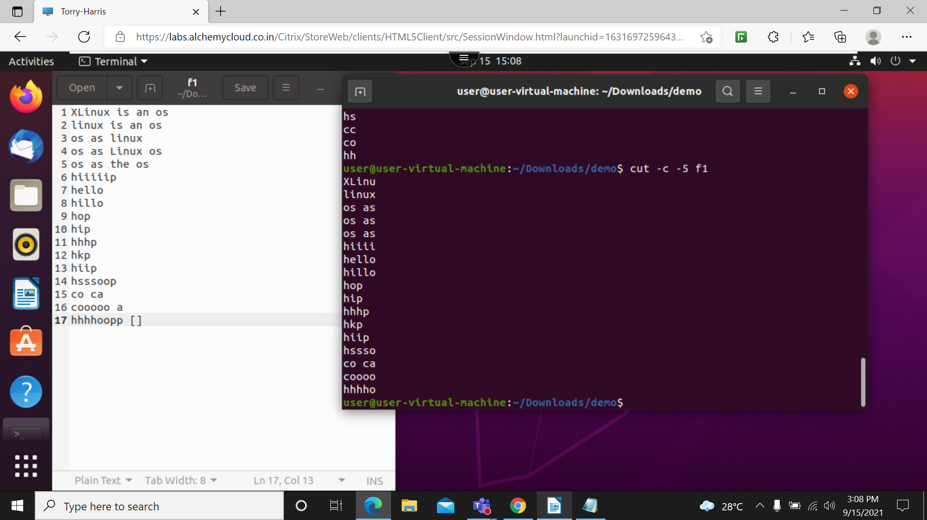

36. cut -c 1,5-7 f1: It will print 1st character and 5 to 7

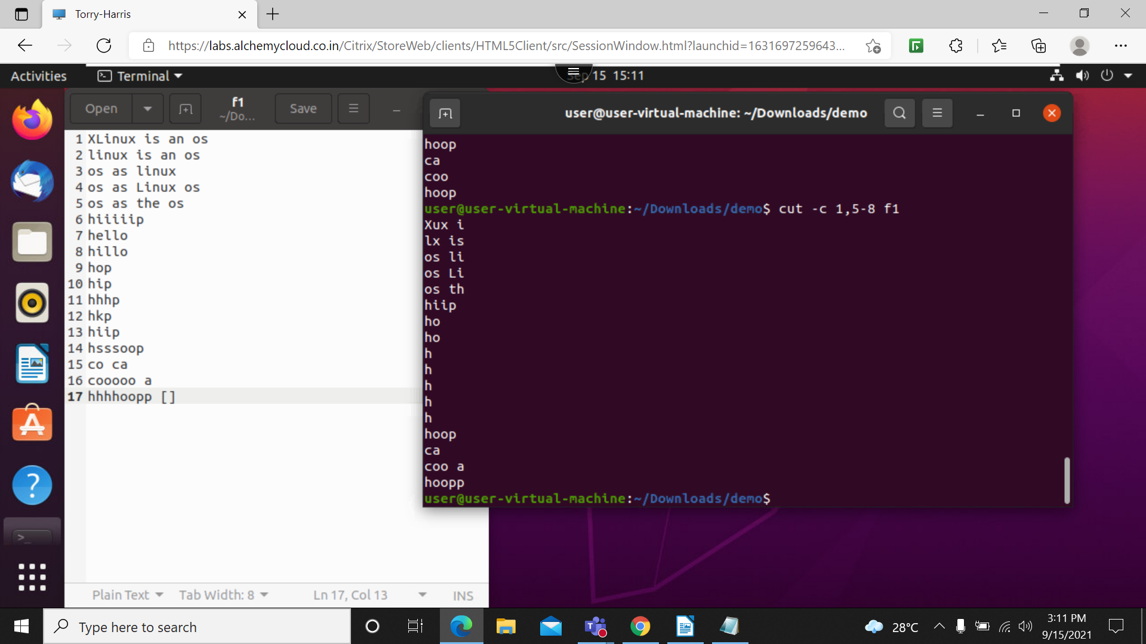

37. cut -b 1 f1: it will cut 1st character from the sting
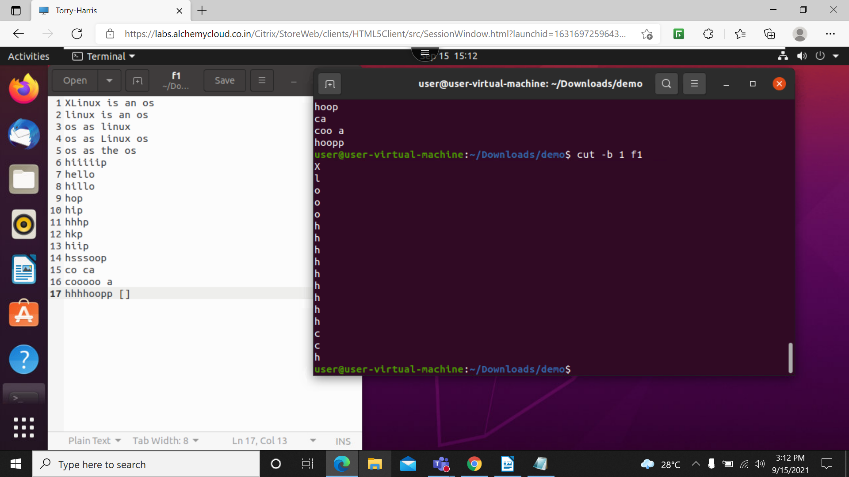

38. cut b 17 f1: it will print 1 to 7 character from the string

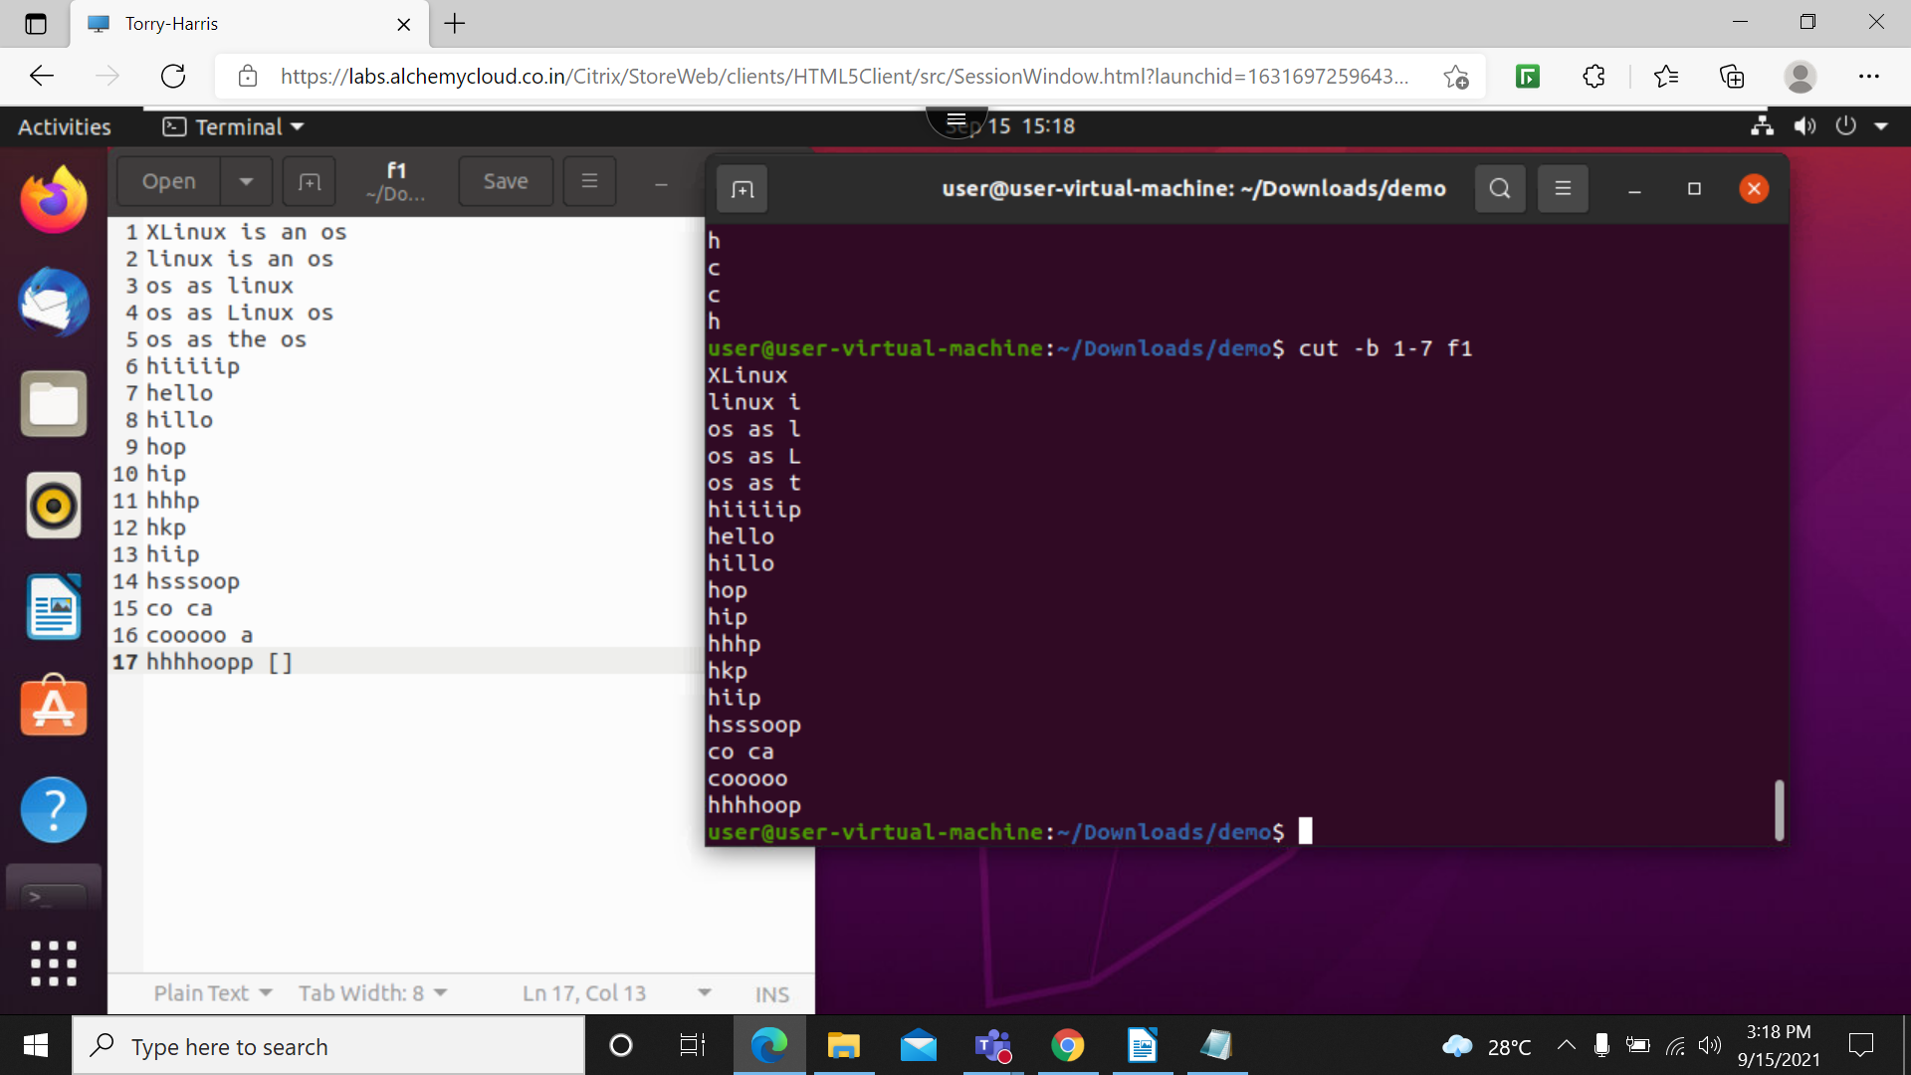

39. cut -f 1 f1 : this will cut the all the strings in file
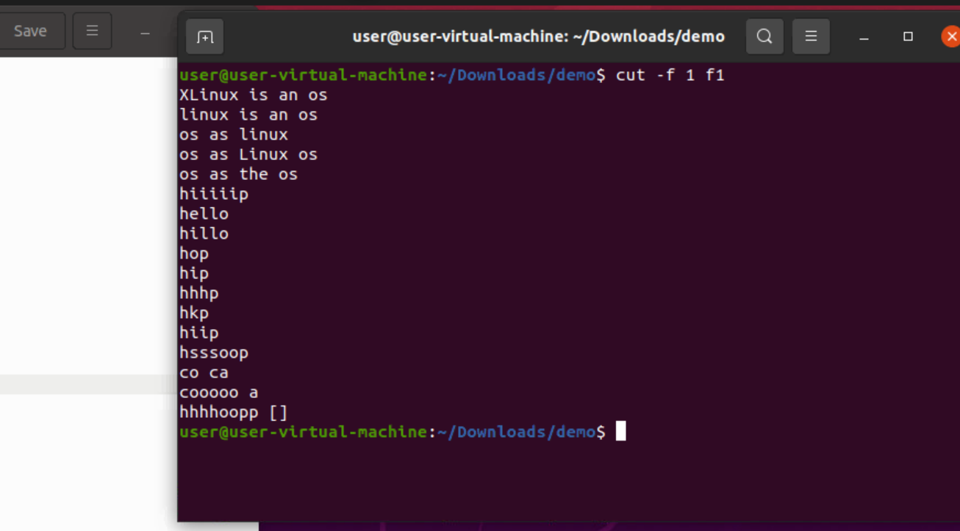

40. cut -d ‘ ‘ -f 1 f1: it will print all the files in f1 till the 1st space
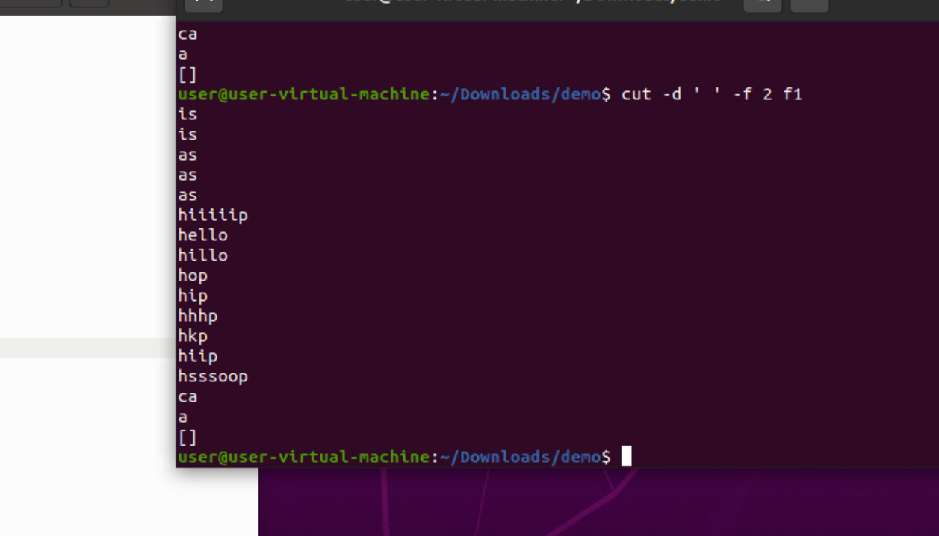

41. cut -d ‘ ‘ -f 2-4 f1: this will print character from space 2 to 4
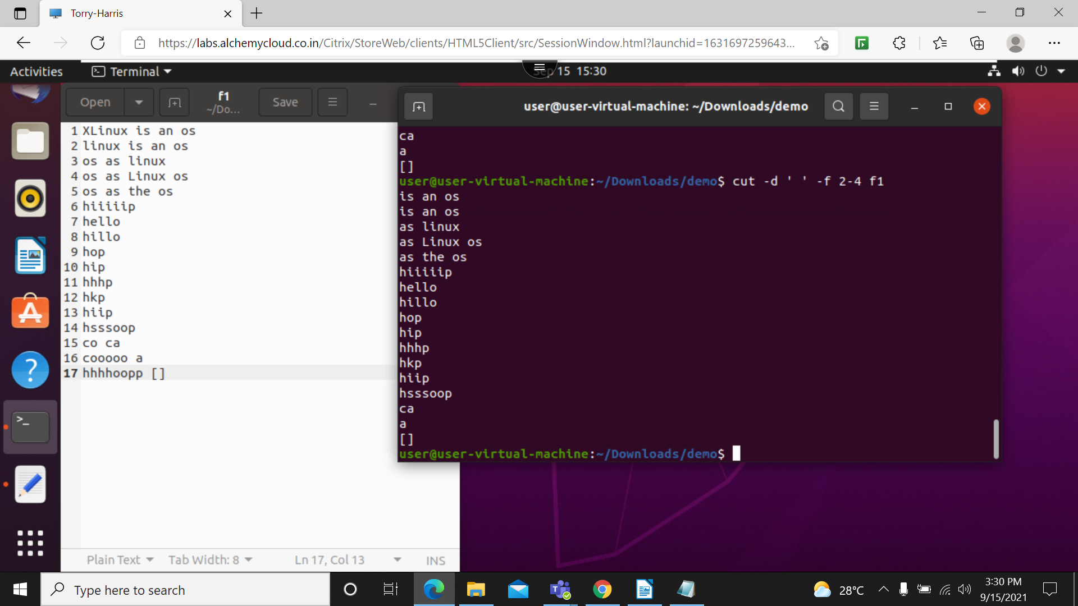

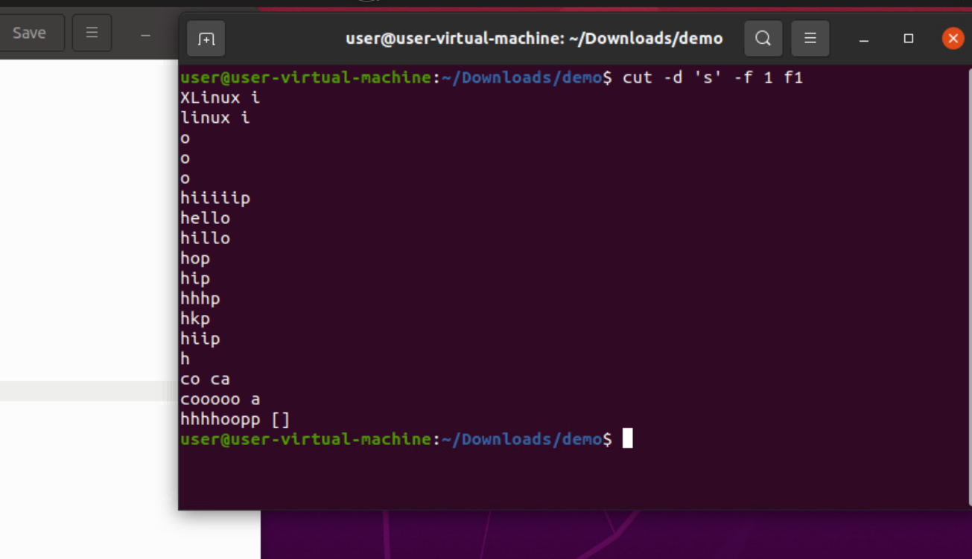
42. cut -d ‘s’ -f 1 f1: this will print all the character before the s in column

43. cut -d ‘s’ -f 2 f1: this will print character from 2nd space to s
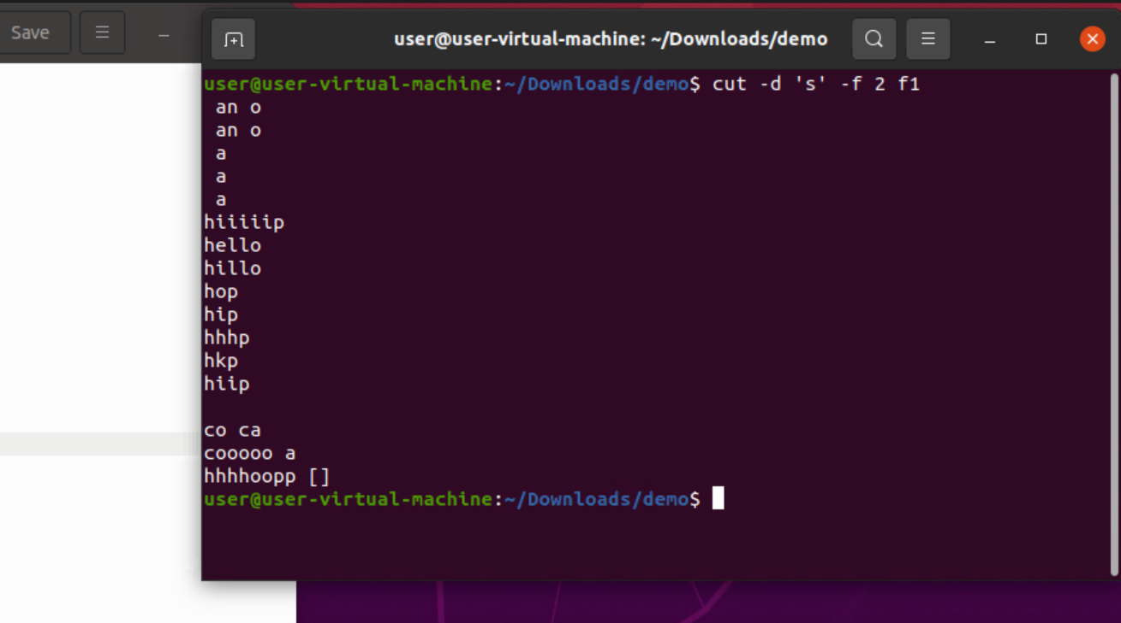

44. cut -d ‘s’ -f 2 f1 :
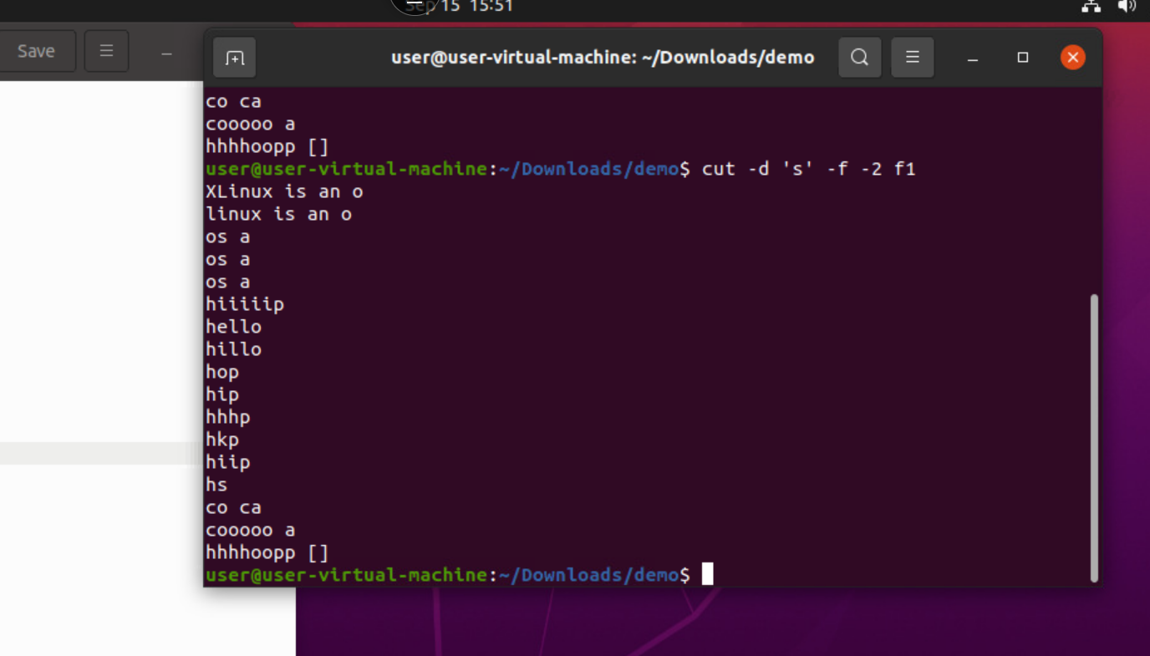

45. cut -c 2-4,6- f1: this will print all the character except 1 nd 5
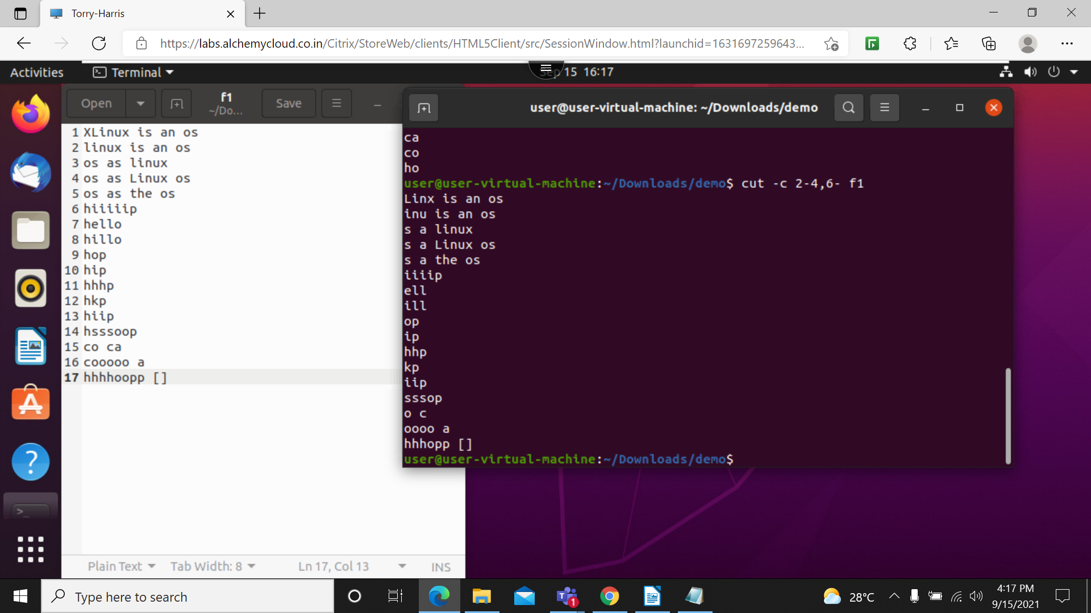

46. cut –complement -c 1,5 f1: iw ill print all charectors except 1 and 5
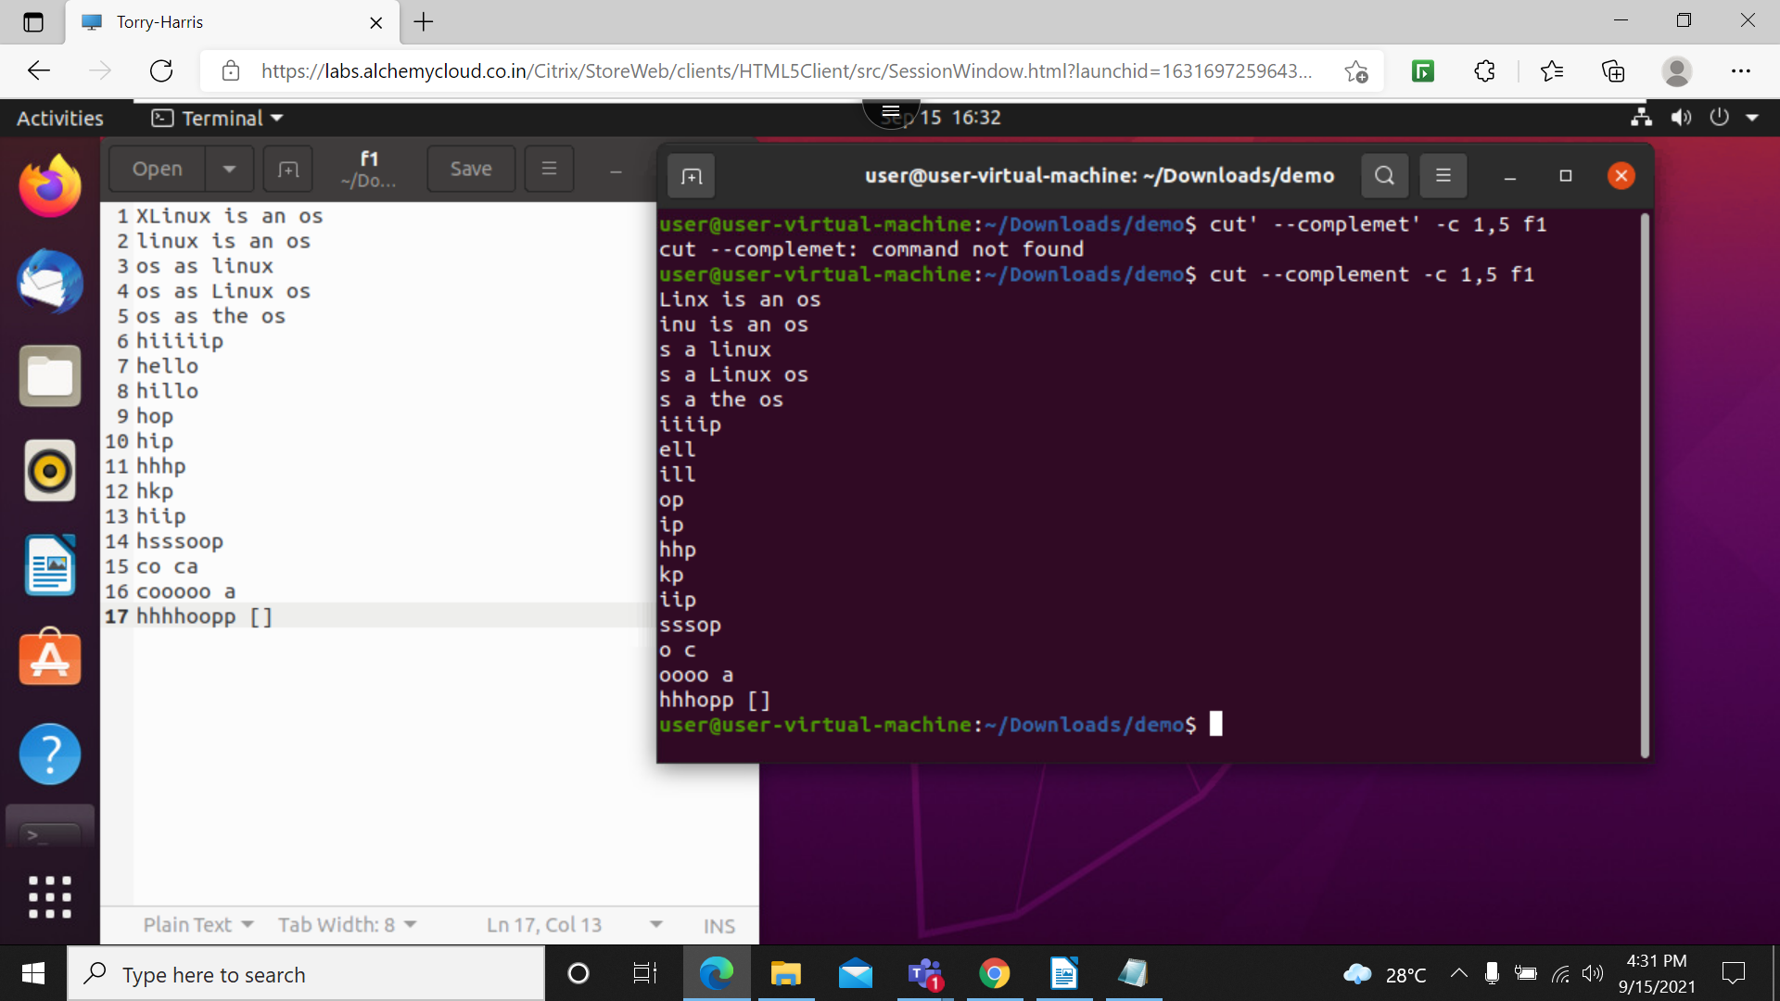

47. cut –complement -d ‘ ‘ -f 3 f4: it will delete the 3rd character
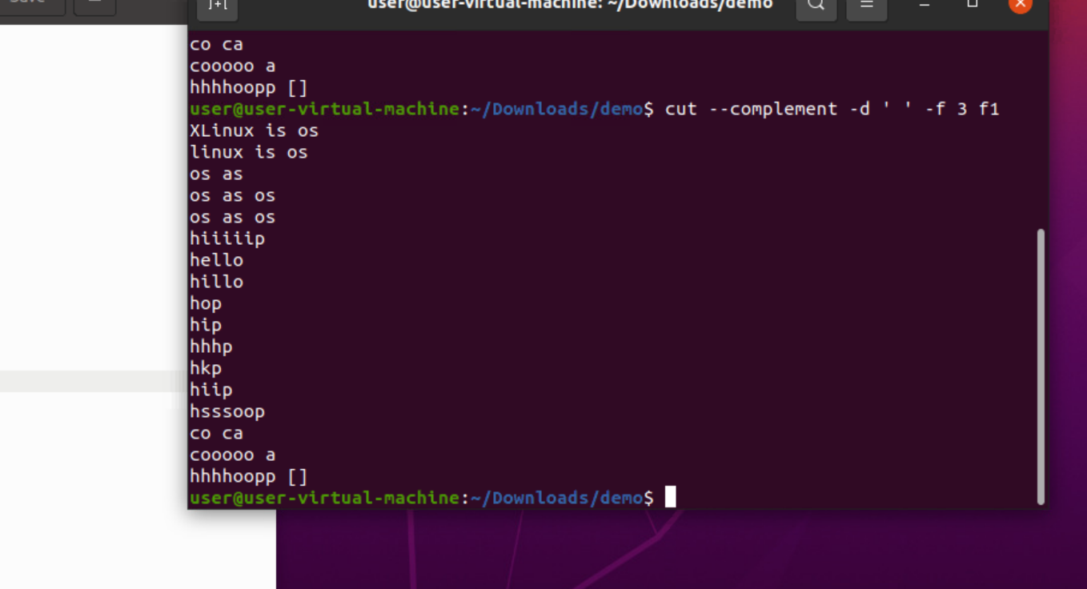

48. . cut –complement -d ‘ ‘ -f -2 f4: it will print all the character after the 2nd column
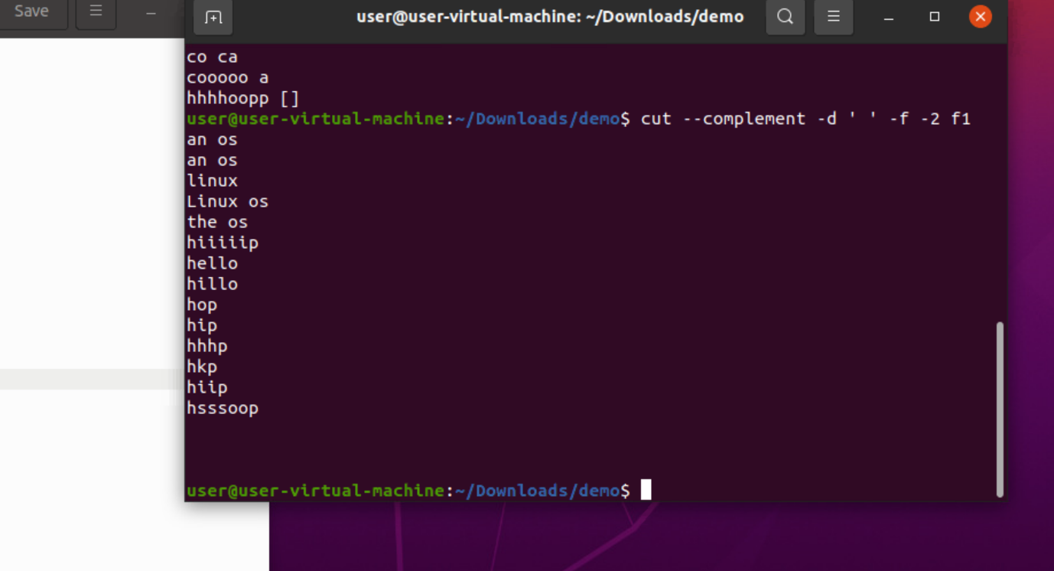

49. cut –complement -d ‘ ‘ -f 1-5 f1: it will delete the strings from 1 to 5

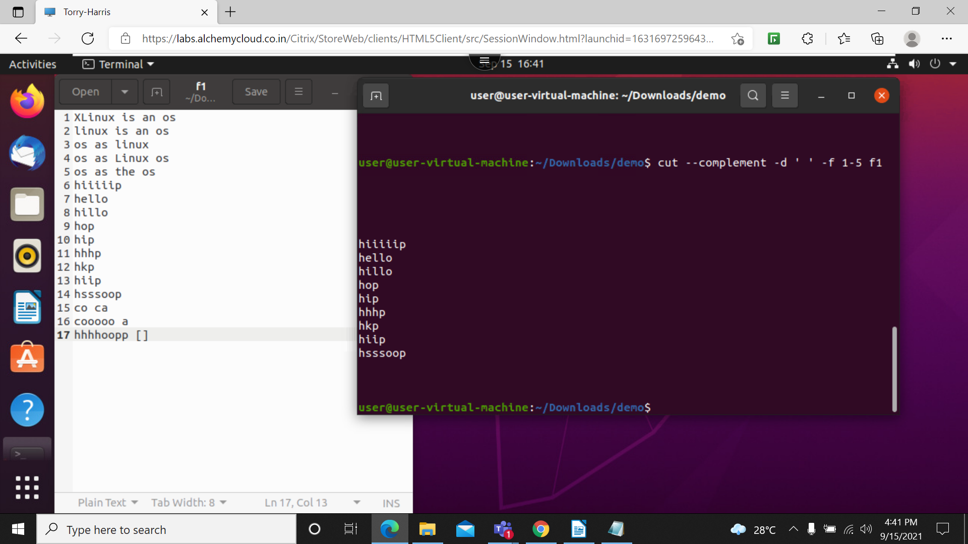

50. cut -d ‘ ‘ -f 1 f4 –output-delimiter= ‘*’: this will delete the 1st space put the *
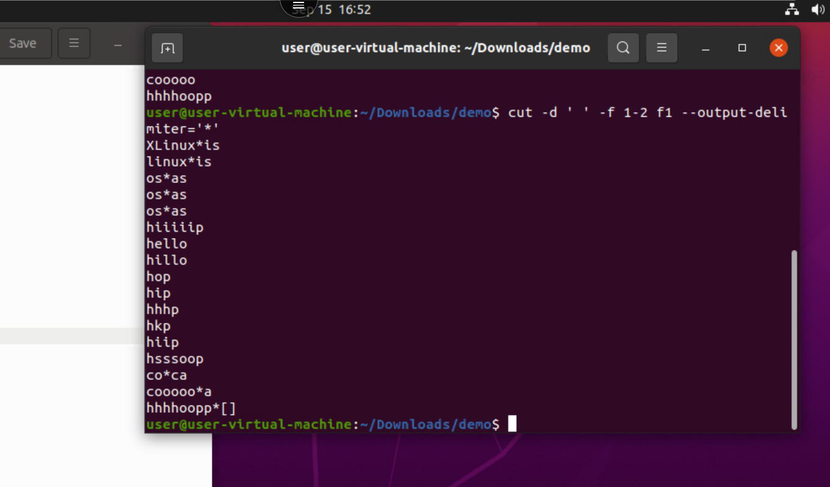

51. cut -d ‘ ‘ -f 1 f4 –output-delimiter= ‘+’: space will replace with +
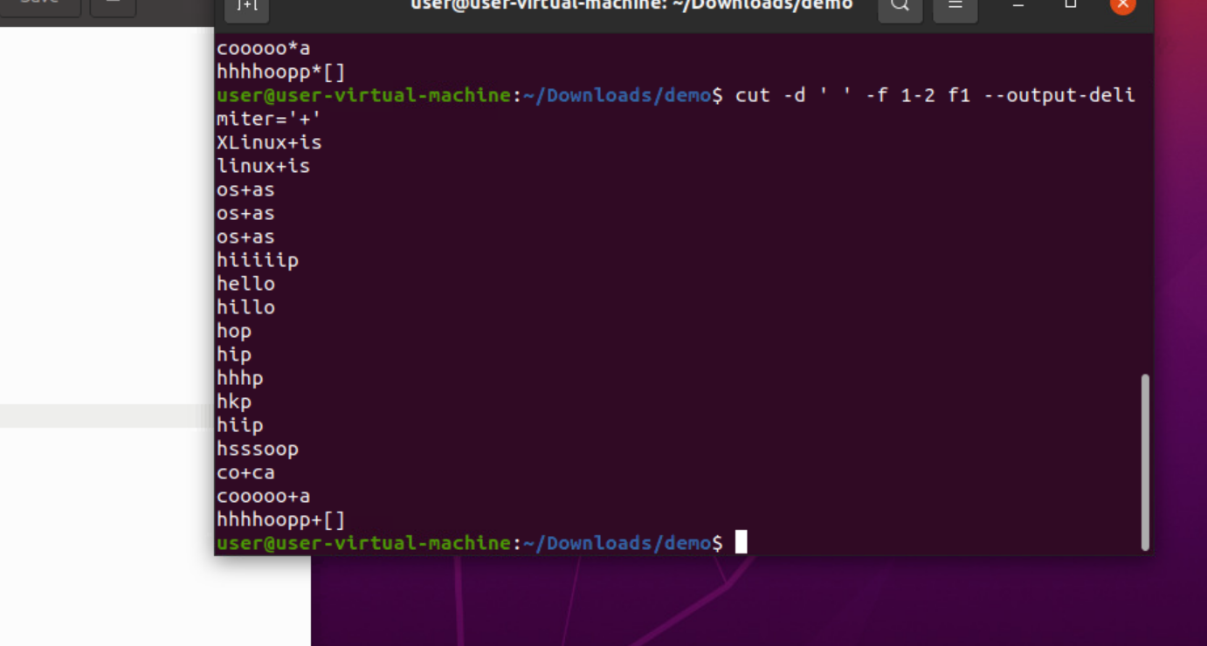

52. cut -d ‘ ‘ -f 1 f4 –output-delimiter= ‘+’>d2: this will create new file and add the changed data into new file
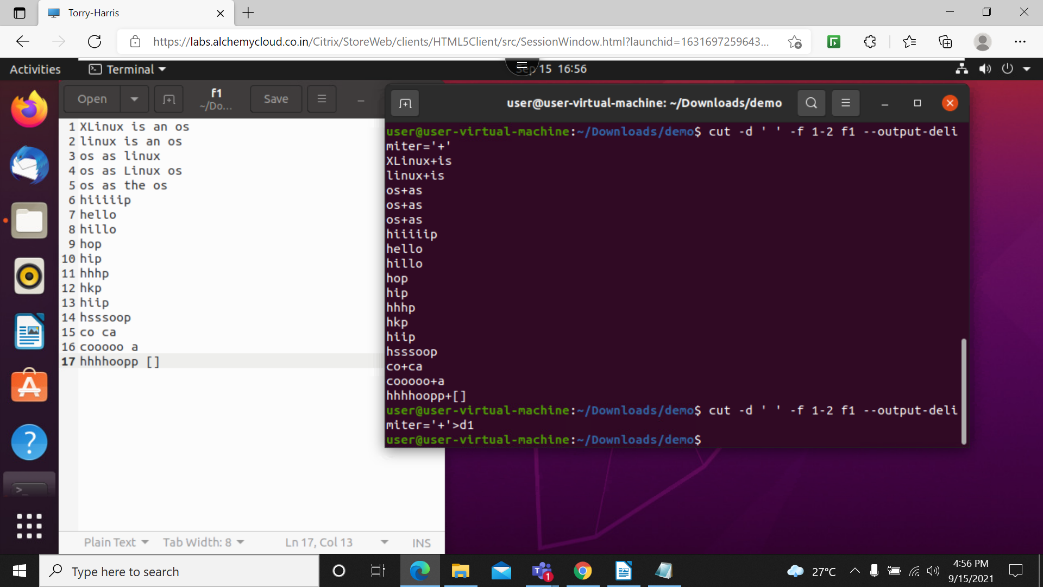

53.cat f1 | cut -d ‘ ‘ -f 1 | sort -r:
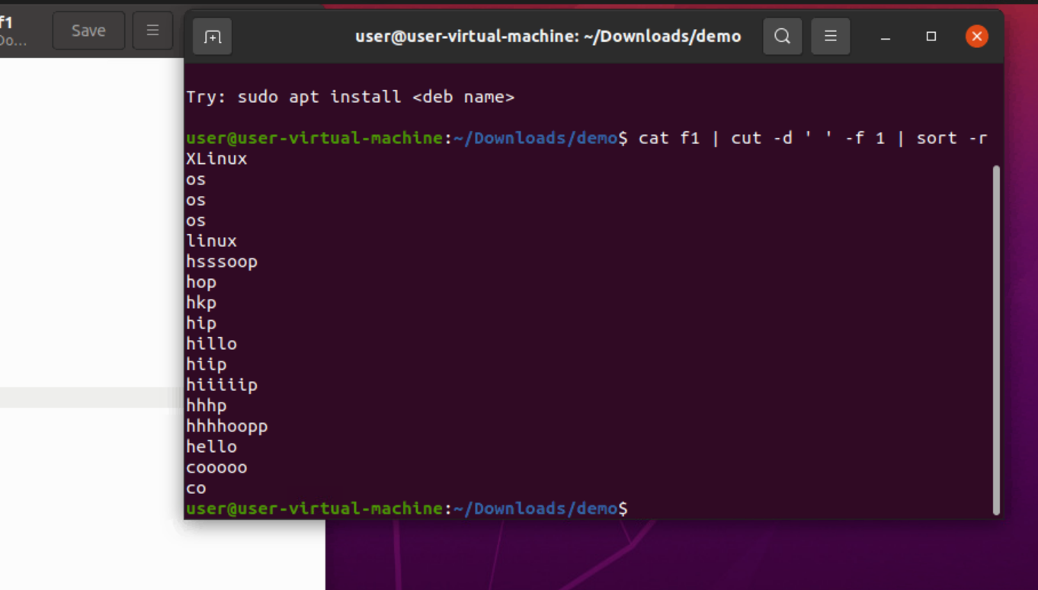

54. cthis will convert the upper case in to lower cases
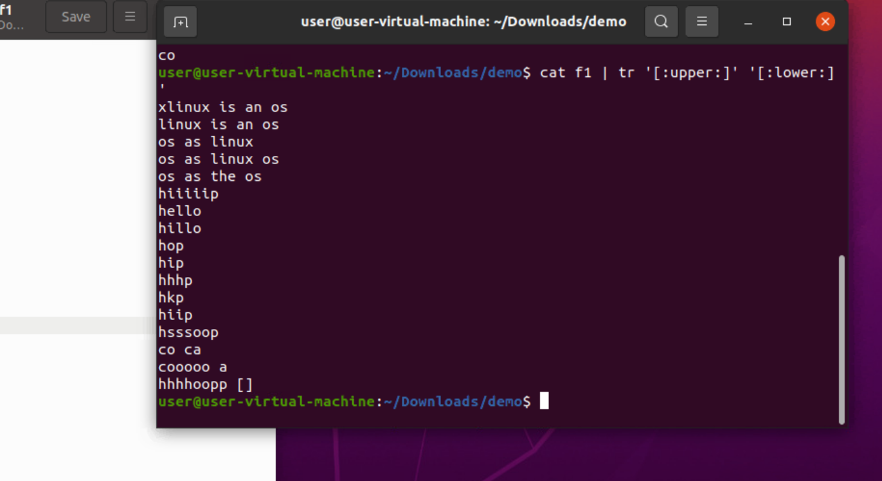

55. cat f1 | tr ‘[:lower:]’ ‘[:upper:]’: it will change dat from lower case to upper case-sensitive
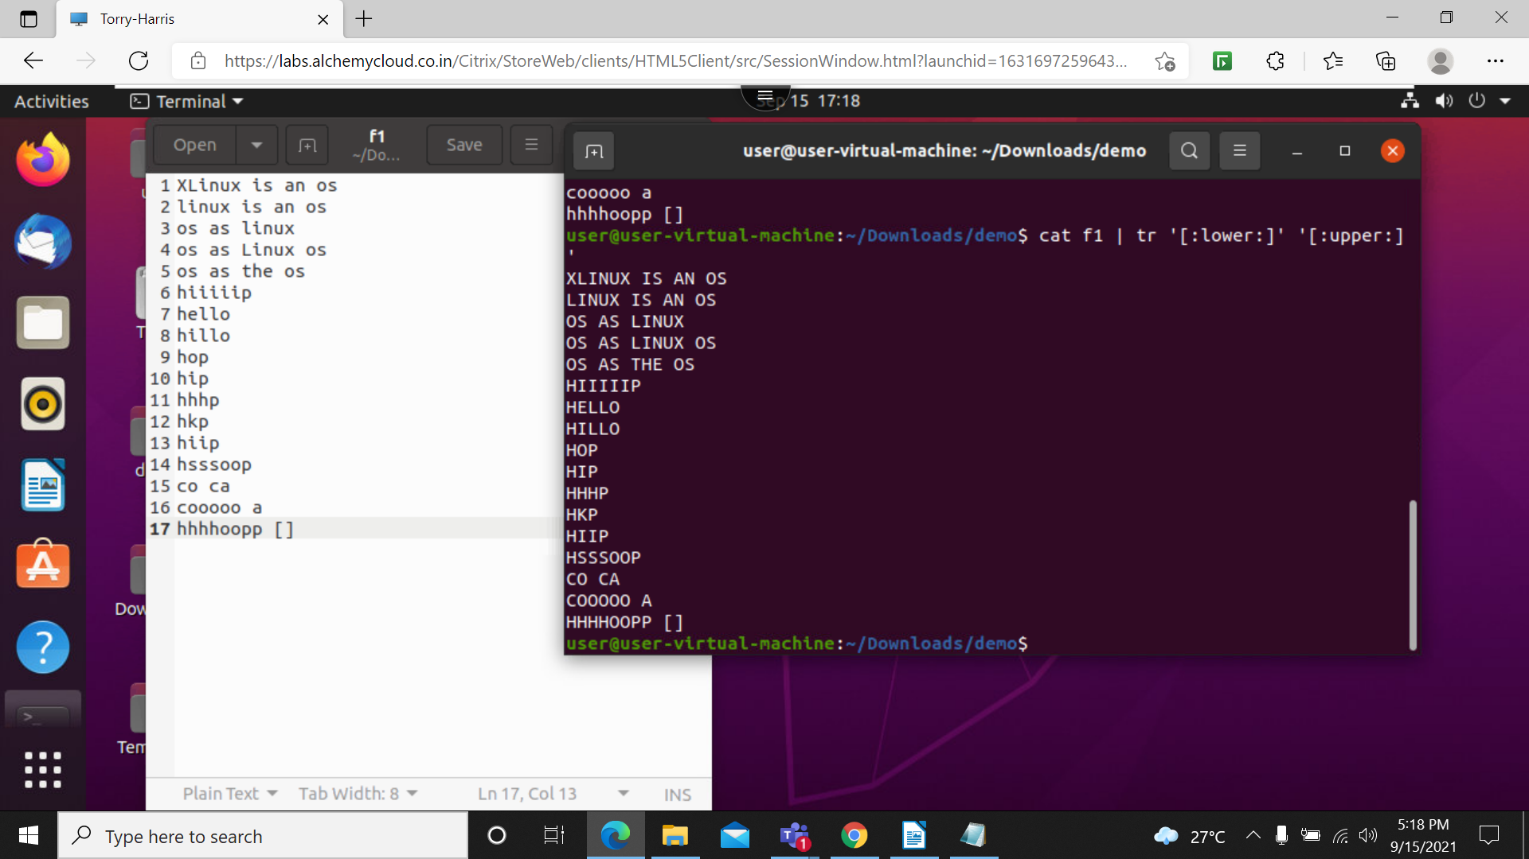

56. echo’hello’: this will print the msg during runtime
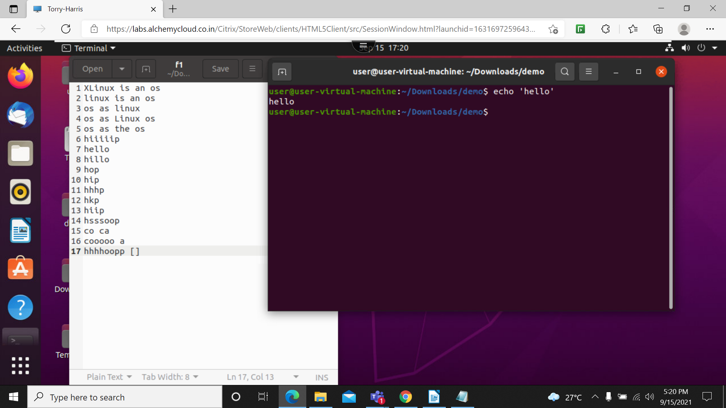

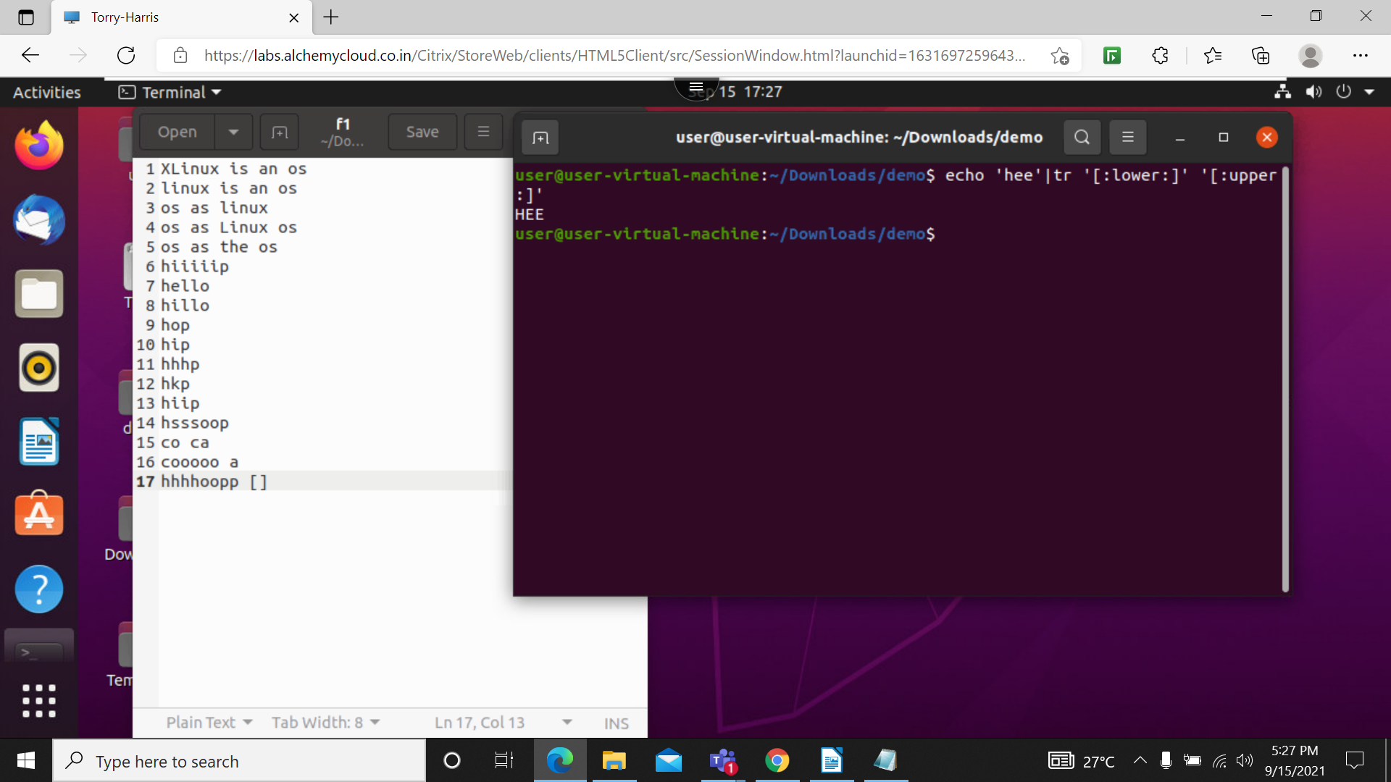
57. echo ‘hee’ |tr ‘[:lower:]’ ‘[:upper:]’ : it will change message from upper case to lower case

58. cat f1|tr -d ‘[:space:]’: this will delete the space

59. cat f1 | tr ‘i’ ‘k’: this will replace the character of I to k
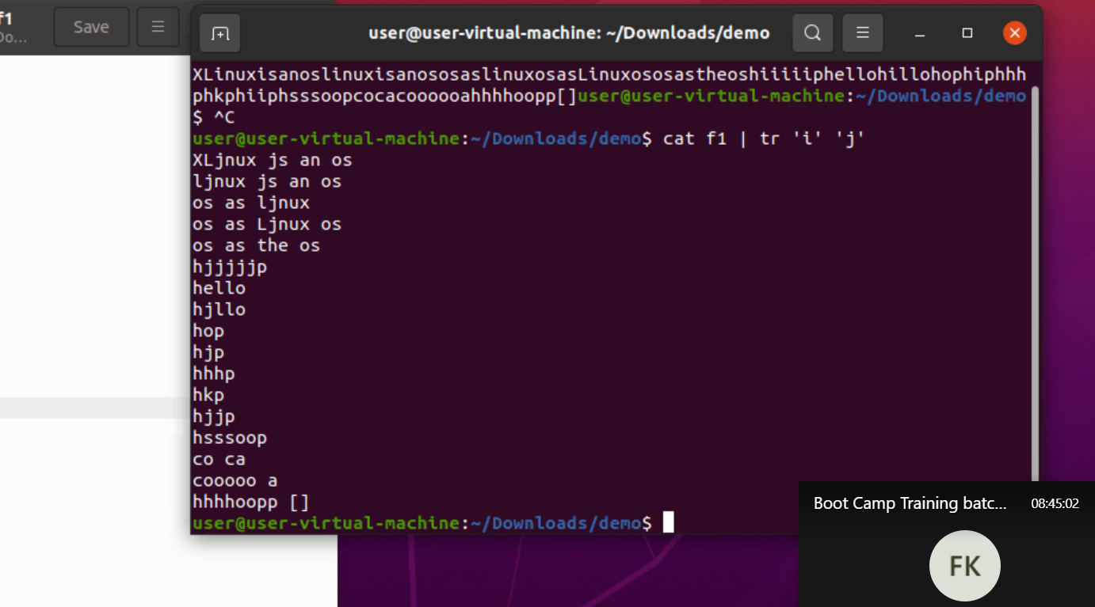

60. cat f1 | tr [il] [Kj]: this will replace il to Kj
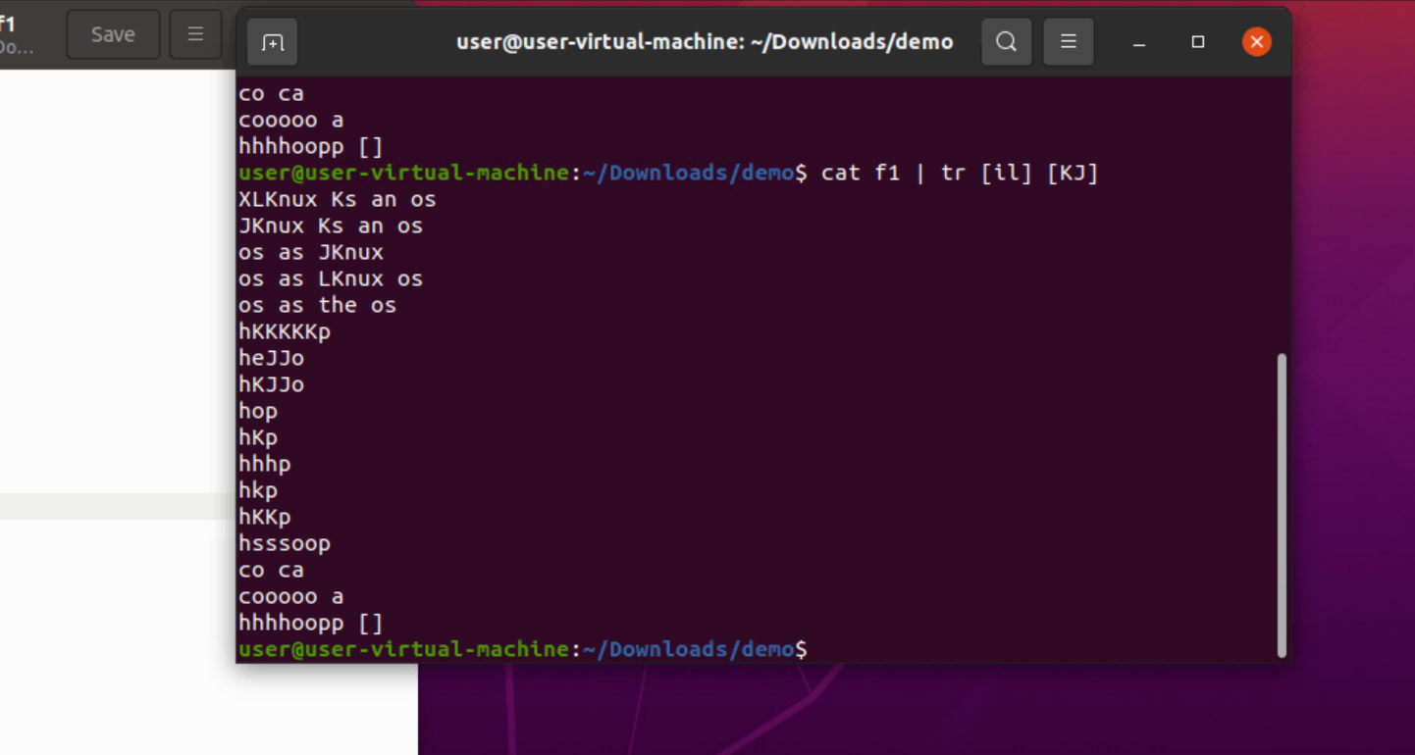

61. cat f1 | tr ‘{}’ []: this will change the brases
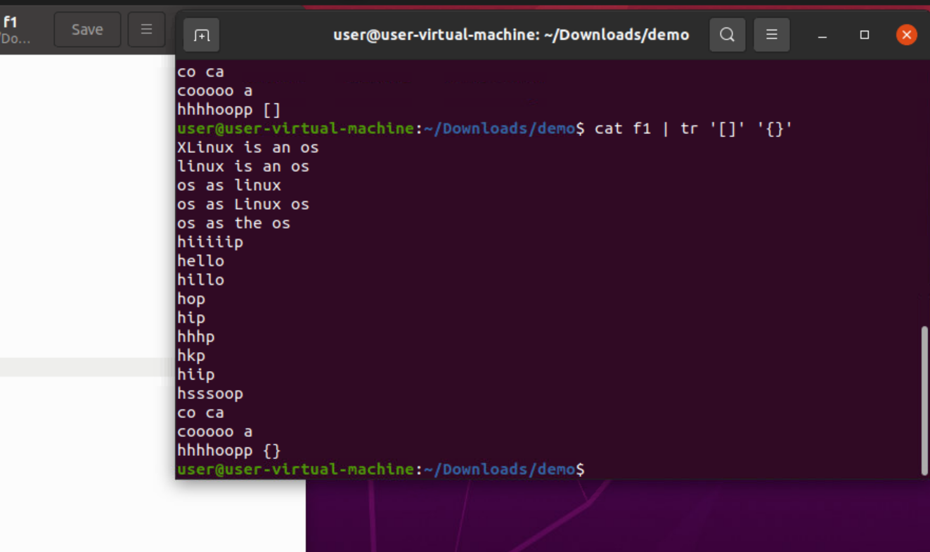

62. cat f1 | tr -s [:space:]:
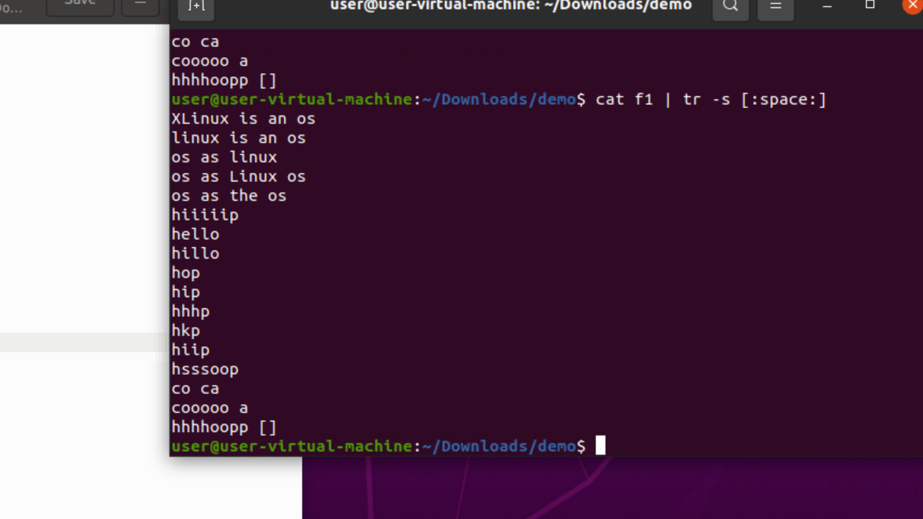

63. cat f1 |tr -d ‘i’: this will delte all I
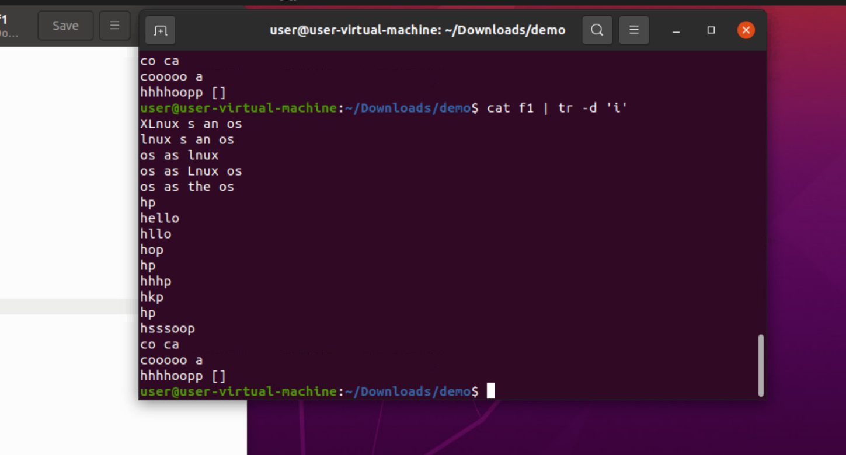

64. cat f1|tr -d ‘[:digit:]’:this will delete the digits
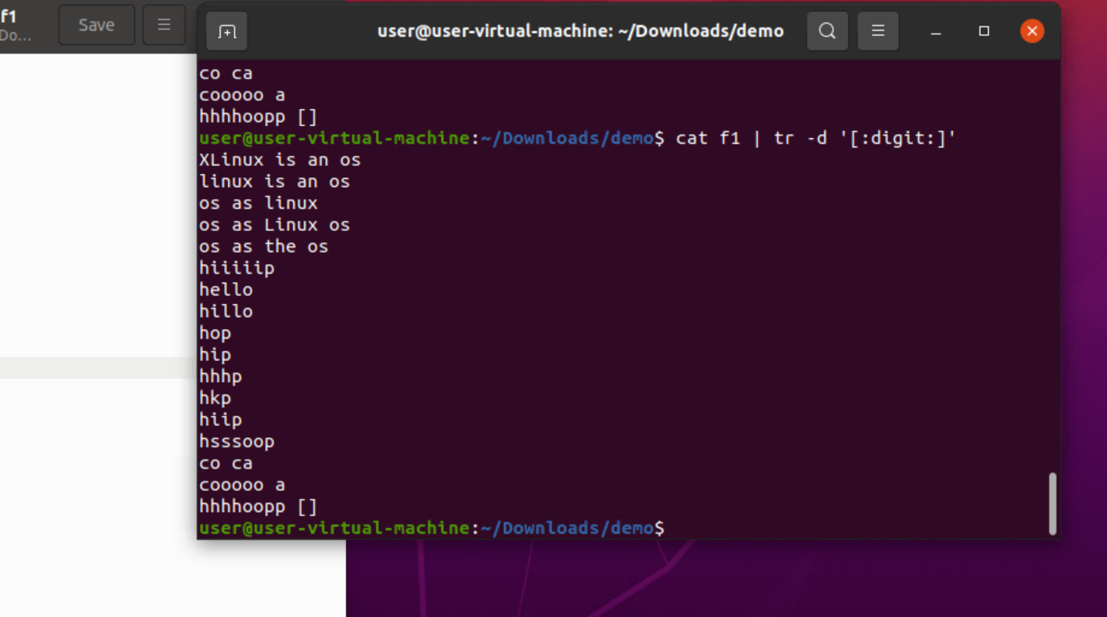

65: cat f1|tr -d ‘[hel]’: this will delete hel
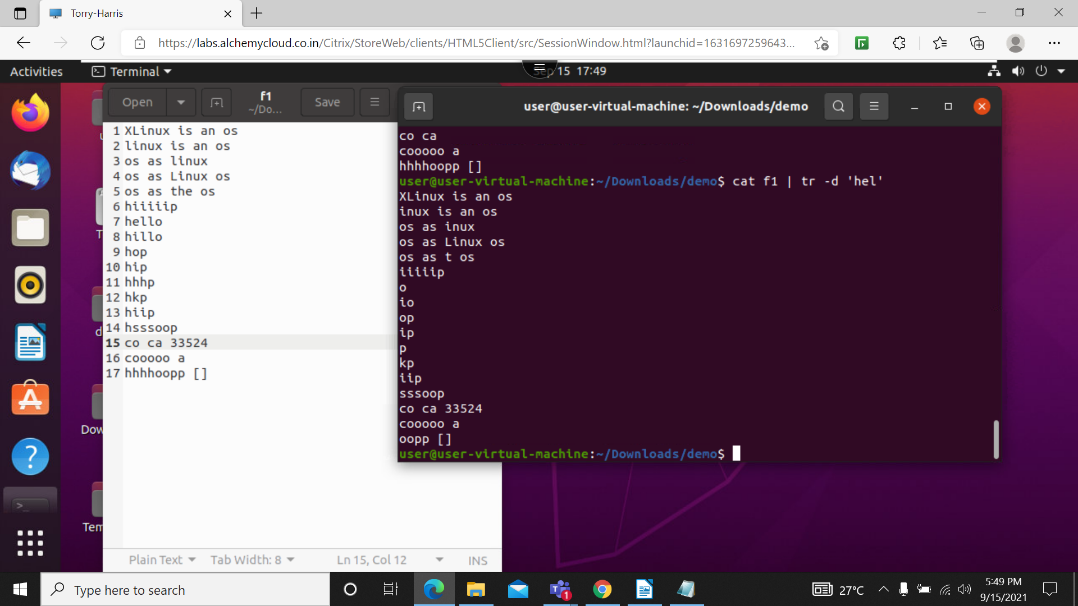

66. more : this will display whole file in in terminal


